1. Write a SELECT statement that returns these columns:

The count of the number of orders in the Orders table

The sum of the TaxAmount columns in the Orders table

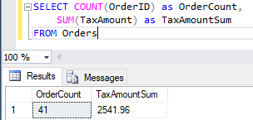

2. Write a SELECT statement that returns one row for each category that has products with these columns:

The CategoryName column from the Categories table

The count of the products in the Products table

The list price of the most expensive product in the Products table

Sort the result set so the category with the most products appears first.

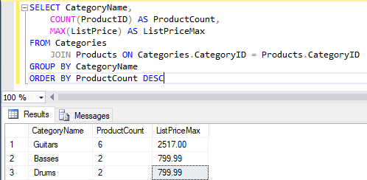

3. Write a SELECT statement that returns one row for each customer that has orders with these columns:

The EmailAddress column from the Customers table

The sum of the item price in the OrderItems table multiplied by the quantiy in the OrderItems table

The sum of the discount amount column in the OrderItems table multiplied by the quantiy in the OrderItems table

Sort the result set in descending sequence by the item price total for each customer.

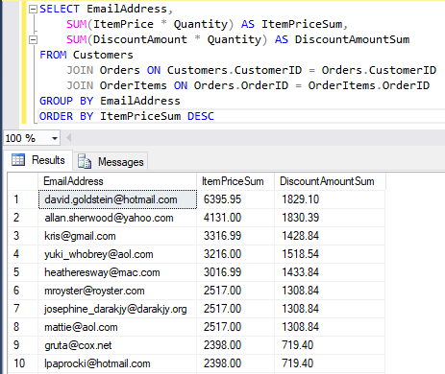

4. Write a SELECT statement that returns one row for each customer that has orders with these columns:

The EmailAddress column from the Customers table

A count of the number of orders

The total amount for those orders (*Hint: First, subtract the discount amount from the price. Then, multiply by the quantity.*)

Return only those rows where the customer has more than than 1 order.

Sort the result set in descending sequence by the sum of the line item amounts.

5. Modify the solution to exercise 4 so it only counts and totals line items that have an ItemPrice value that’s greater than 400.

6. Write a SELECT statement that answers this question: What is the total amount ordered for each product? Return these columns:

The product name from the Products table

The total amount for each product in the OrderItems table (*Hint: You can calculate the total amount by subtracting the discount amount from the item price and then multiplying it by the quantity*)

Use the WITH ROLLUP operator to include a row that gives the grand total.

7. Write a SELECT statement that answers this question: Which customers have ordered more than one product? Return these columns:

The email address from the Customers table

The count of distinct products from the customer’s orders